Quick Steps to Log into Clever
- Click here to access: Clever
- Click on bottom choice, Log in with Clever
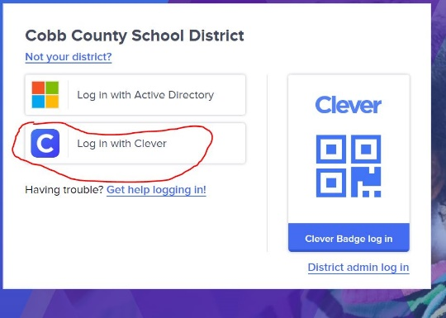
- Then, students should use their student ID number as the username AND AGAIN as the password.
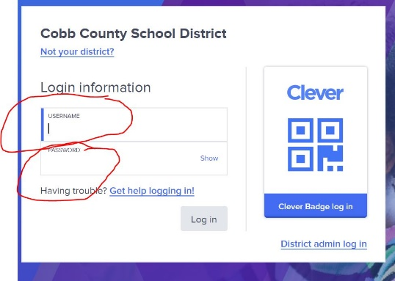
- You will be asked to create a new password, but enter their Student ID number again in both boxes.
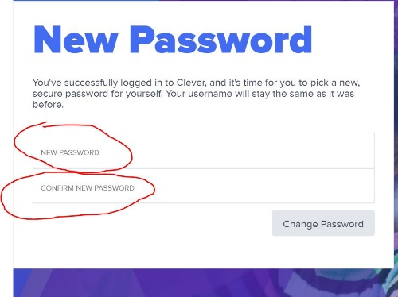
- You are in!

