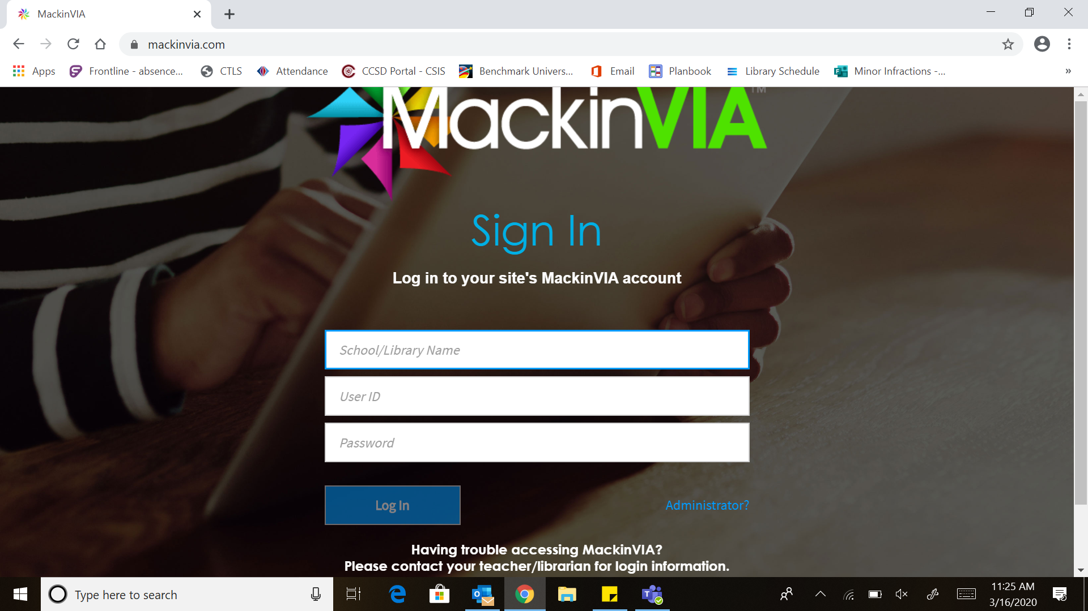
- Choose “Chalker” from the list of schools. Then, it will look like step 2.

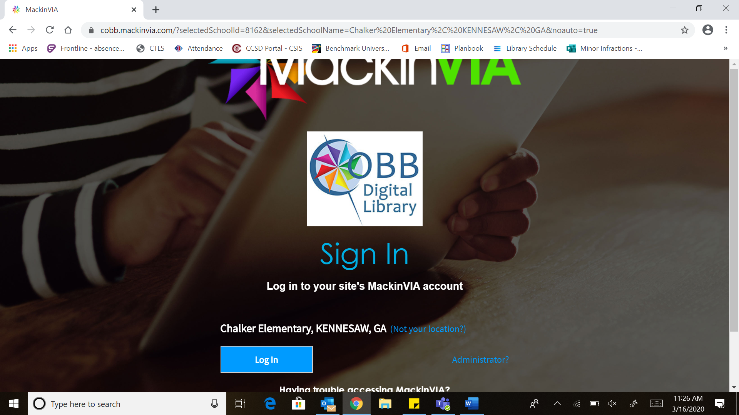
- Click “log in” and then it should look like below:
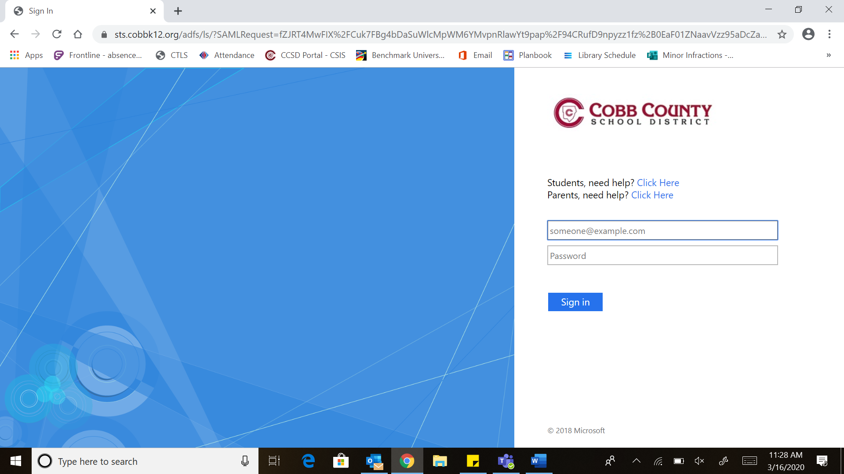

- Type student email/ Office 365 username firstname.lastname@students.cobbk12.org
- Type password “123” “321” or student number (it should be one of these). Then, it should look like below:
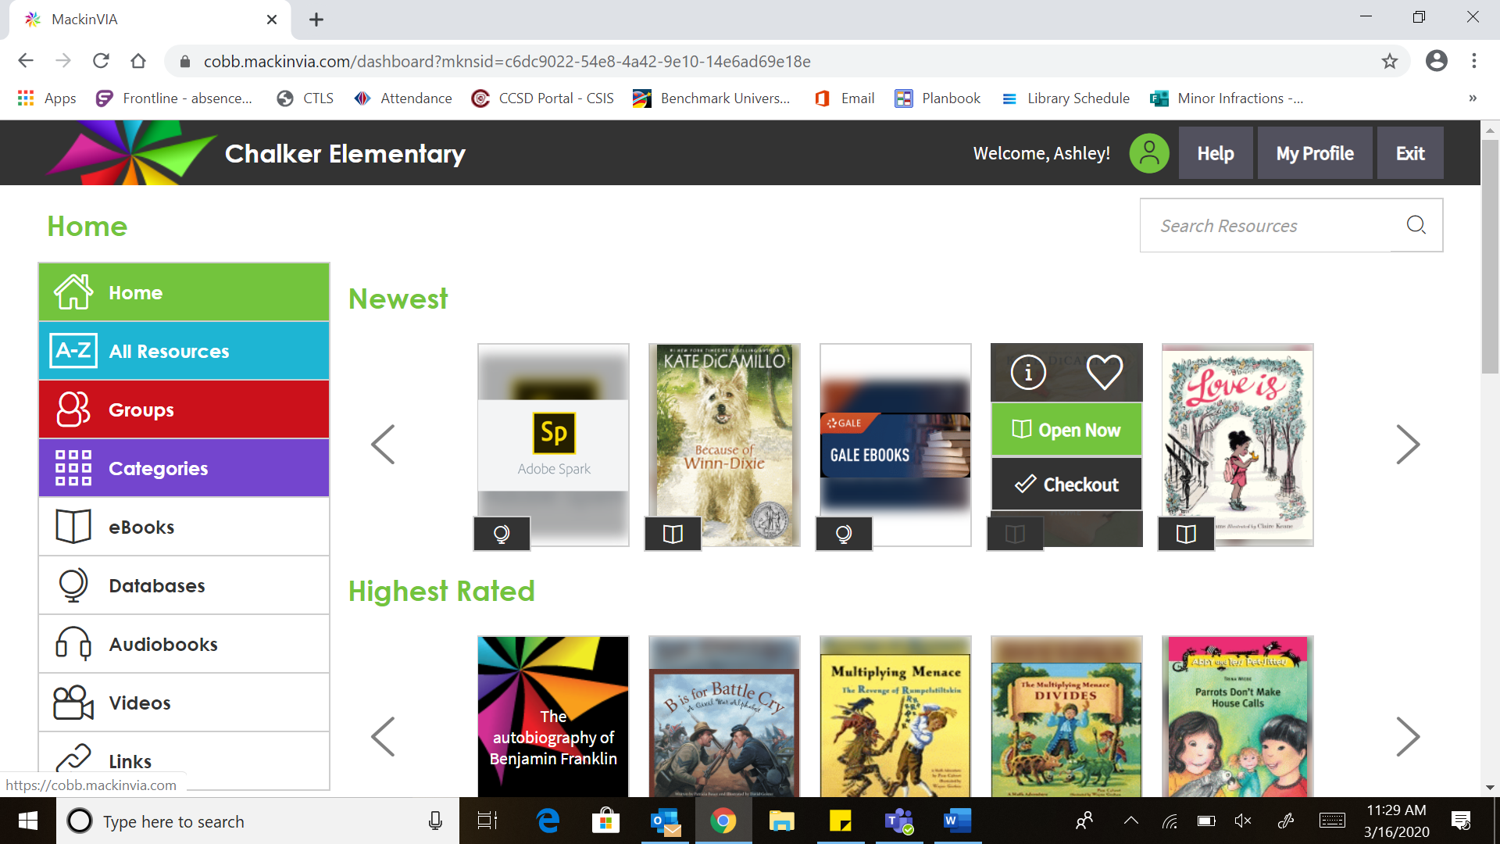
- Here is where you would type brainpop jr.

